

Information for Modelling on Regional Anaesthesia courses

COURSE NAME:-
COURSE DIRECTOR:-

Thank you for considering being a model. This information sheet will help you to understand what is involved, and to help you to decide if you want to take part.

What is the course for?
The aim of the course is to teach anaesthetists to perform ultrasound guided nerve blocks. Part of this procedure is to use an ultrasound to see where the nerves run. Scanning real life models helps demonstrate normal anatomy in healthy volunteers. Delegates attending the course will get to practice using the ultrasound machinery, as well as learn the anatomy by seeing it for themselves on volunteers. The main purpose is to get lots of hands on experience by scanning volunteers in a safe learning environment. You will only be scanned, you will not receive any injections.

Benefits of attending
Modelling on a regional anaesthesia course is an excellent way to learn about this area of medicine, especially for those who are considering a career in anaesthesia. You will be involved in small group teaching from experts in the field, and ultrasound is an excellent way to consolidate anatomical knowledge. You will also be able to attend talks between modelling session. Many models volunteer for subsequent courses and find the experience interesting and rewarding.

Who are the delegates?
The delegates will be Doctors or allied healthcare professionals. Most will have some experience of using an ultrasound already but some will be beginners.

What to expect?
Workshops:- Scanning sessions will be run by experienced senior doctors who scan patients and perform nerve blocks regularly. They will be supervising a small group of delegates who will take it in turns to scan the volunteers. Each session of scanning is likely to be separated into different sessions, for example scanning the abdomen, lower limbs, upper limbs, and back. The facilitator will explain what they will be scanning before each session and what position they may need you to be sitting in or lying on the couch.

You may be asked to expose some areas to scan that are not easily accessed and you may need to move clothing straps. This could also be the hip/inguinal canal area, but you will not be asked to expose any intimate areas.

Occasionally courses include the scanning of the sciatic nerve either just below the buttock or above. We recommend that courses specifically inform you beforehand if this is planned as some models may not feel comfortable with this. You do not have to participate in this type of scan if you do not feel comfortable doing so.

Lectures and talks:- Live model scanning is sometimes used during a lecture or talk. This will be in front of a larger audience, but will otherwise be similar to scanning during a workshop. Sometimes lectures are filmed or streamed to online delegates. You will be informed if a recording is to be made and you will not be filmed without your permission. Most of the models will not be required to model on the main stage.

What to wear?
Ideally wear loose clothing that you don’t mind getting covered in the ultrasound jelly (don’t worry it washes out no problem!)
Shorts, T-shirts, strappy tops or vests are ideal, but whatever you feel comfortable in and can allow access to the trunk, lower limb, back and upper limb. You can change into this on the day once you arrive at the venue.
Blankets will be provided for warmth and to provide dignity, but models will NOT be required to remove underwear.

Things to be aware of:
Preparation
- In some workshops, it is necessary to have an empty stomach or a full bladder. You will be informed in advance if this is required and efforts will be made to minimise discomfort.

Ultrasound jelly
- Will be used for all scans on the skin
- It is water based and should not cause any irritation to the skin
- Clothing will regularly come into contact with the jelly, but it comes out easily in the wash and does not damage clothing.

Scanning
- You may feel some pressure from the ultrasound from the scanning, if it’s too much pressure please say! Delegates will also appreciate if you tell them if their technique is uncomfortable because this is their time to learn and for feedback before they do this on patients.
- Certain parts of your anatomy will need to be exposed to get the appropriate scan (please see below images), every effort will be made to preserve your dignity and comfort, so if at any time you do feel uncomfortable please say.

Complications
- The scans performed are NOT diagnostic for any conditions, the purpose of scanning is to identify normal anatomy.
- The anaesthetic doctors who will be teaching use ultrasound regularly but they do not use it to diagnose. It would be very unusual to identify an abnormality on a scan on a healthy volunteer, and in most cases the scanner is not appropriately qualified in diagnostic scanning. In the unlikely event that they have genuine concerns they will tell you and encourage you to seek medical attention and appropriate diagnostics.
- Equally, normal scans should not be considered to be a form of health check.

Privacy
- If you agree to model, you are not automatically consenting to have photographs taken. Delegates and faculty will need to obtain your explicit permission to photograph you, and also permission to share anything on social media.
- Modelling on the main stage during a lecture will be filmed for ‘catch up’ viewing and streamed. Clearly if you do not feel comfortable with this you will not be expected to model on stage.

Conduct
- Teachers and delegates are expected to adhere to a code of conduct (you will also receive this).
- Most importantly if you, at any point, feel uncomfortable for any reason or experience any discomfort please say. You should never be made to feel uncomfortable during this experience.

Point of contact
- If you have any concerns please feel free to raise these with any of the faculty. If you are unsure of who to speak to, the nominated faculty member is
Name:-
Email:-

What will be scanned?
The courses are usually structured into sections for different areas of anatomy. Delegates will be learning about nerve pathways for different areas of the body, and where they can scan to visualise the nerves best.

The most common areas that are scanned are the upper limb and neck, the lower limb, the trunk and abdomen and back. You will be told in advance which areas will be scanned.

(Please note that these torsos appear unclothed, that is only for demonstrative purposes, you will not be expected to be unclothed)

Upper Limb:
- Peripheral nerves: Radial, Median, Ulnar
- Area of scanning: full length of the arm

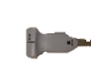

- Brachial plexus/Interscalene
- Area of scanning: armpit/axilla, neck, under collar bone

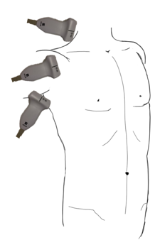

Lower Limb:
- Above and below the inguinal canal
- Inner mid-thigh
- Behind the knee
- Ankle joint

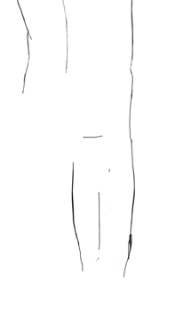
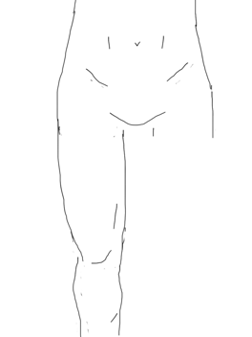

Spine and Back:
- In the middle of the upper and lower back
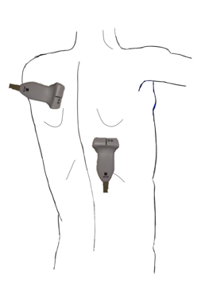

Trunk:
- Over pectoral muscles just below the collar bone
- Middle of the abdomen around to the flanks
(Note none of these scans will be looking at any reproductive organs, they will be looking at superficial structures only).
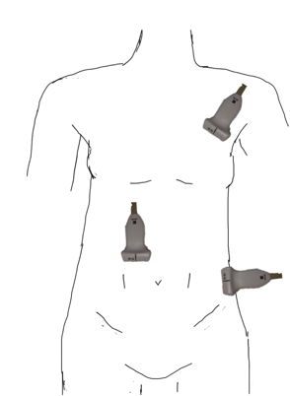

POCUS (Point of Care Ultrasound):
- POCUS is a term to describe the use of ultrasound for examination of a patient. In anaesthesia we tend to use the term to describe the use of ultrasound when a needle is not inserted.
- This includes; Echo scans of the heart, lung scanning, scans to identify stomach content.
- The course organisers may ask you to have an empty stomach. This requires;
  - No food, fizzy drinks or milk for 6 hours before the workshop.
  - You can have clear fluid up to 2 hours before the workshop.

Gastric scanning: (stomach)

Echo: (heart)
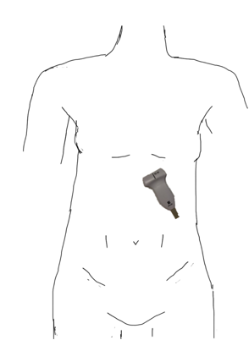
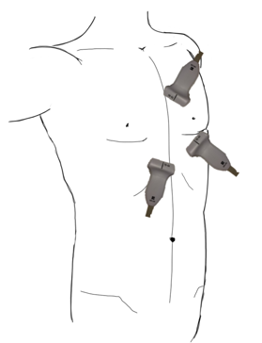

Lung scanning:
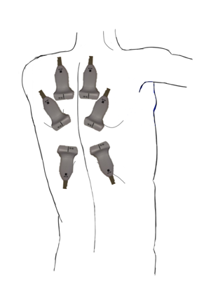
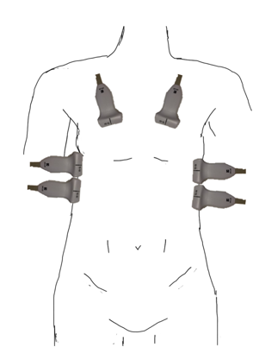

Finally...
We hope you really enjoy helping with the course. We hope that you feel welcomed, find it interesting and learn something new!

